**DBMS LAB-01(05-12-2024)**

**Name-** Bhavya Shrivastava **Roll No-** 23052071 **Section-** CSE-15

1. **Create tables for - Student(student_id, first_name, last_name, dept, Date_of_birth, gender, religion), Employee, Product, Customer, and Account.**

**Identify relevant attributes for each table make sure each table has at least four columns. Ensure each table has an ID column e.g. Employee should have EMPLOYEE_ID column, Student should have STUDENT_ID column etc.**

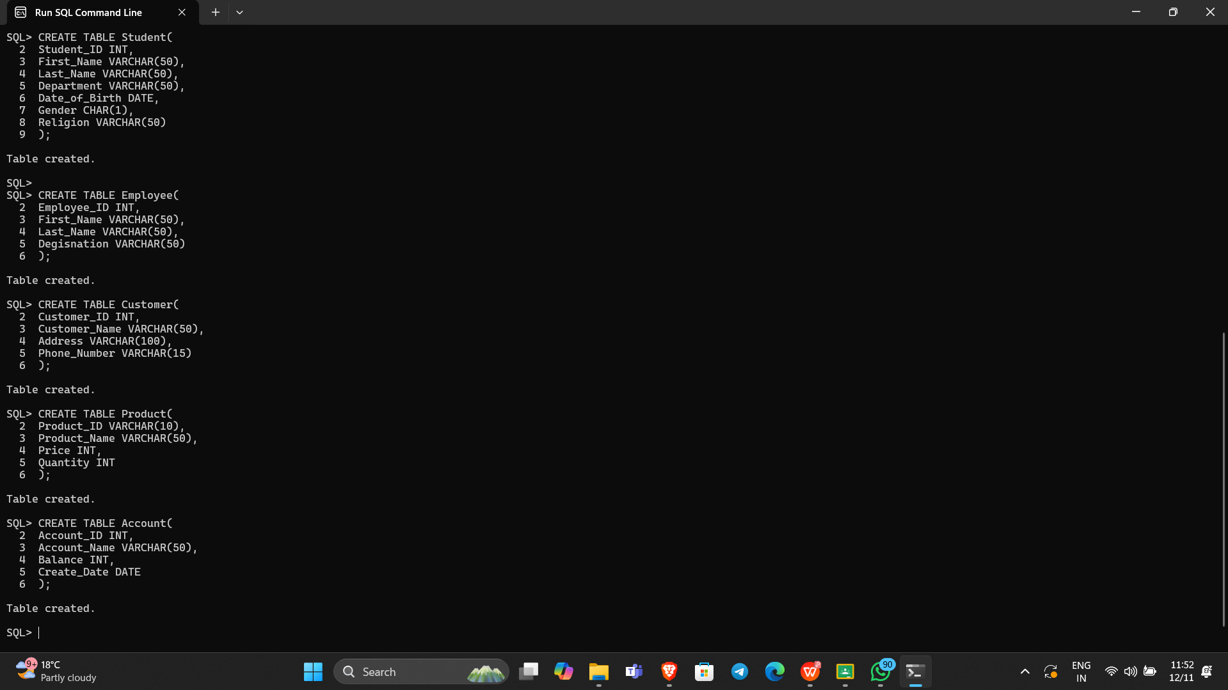

1. **Describe each table.**

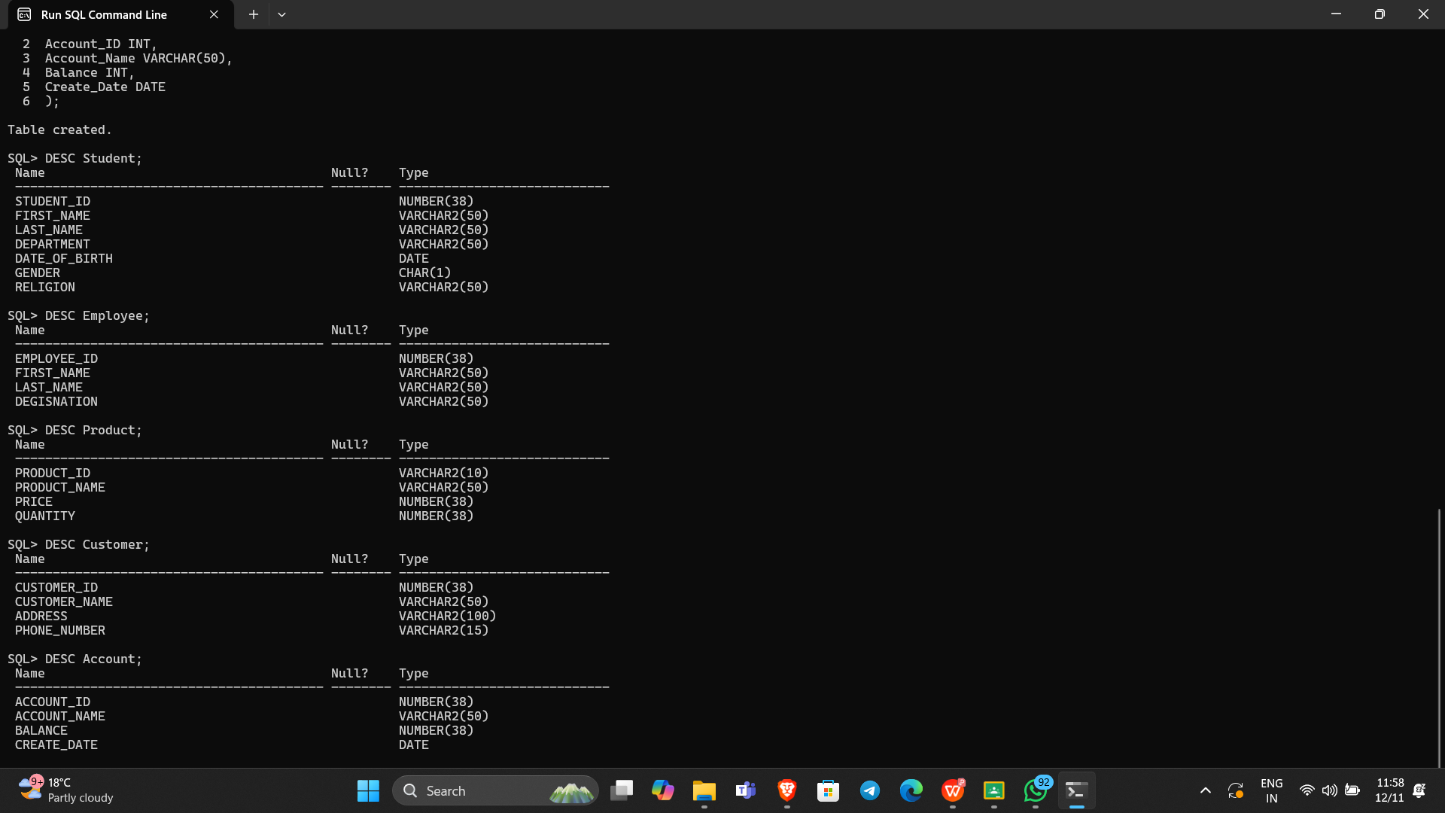

1. **Insert at least 5 distinct rows to each table.**

**Student Table**

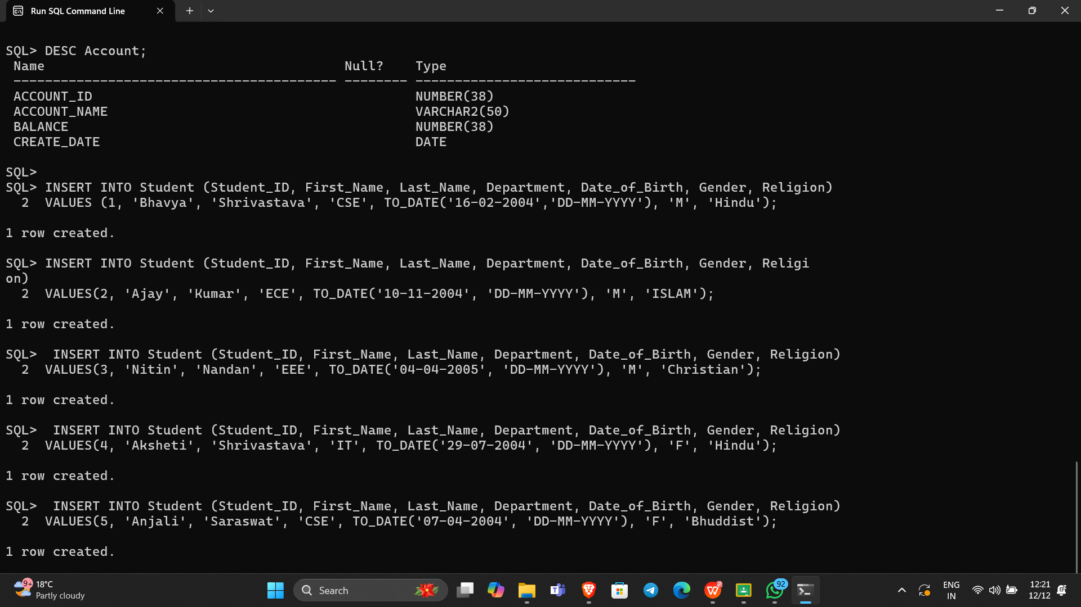

**Employee Table**

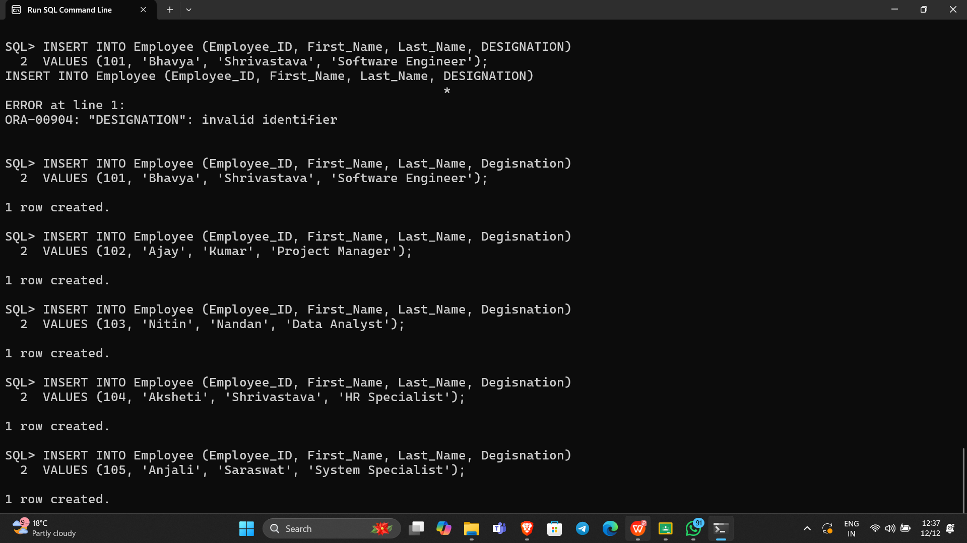

**Product Table**

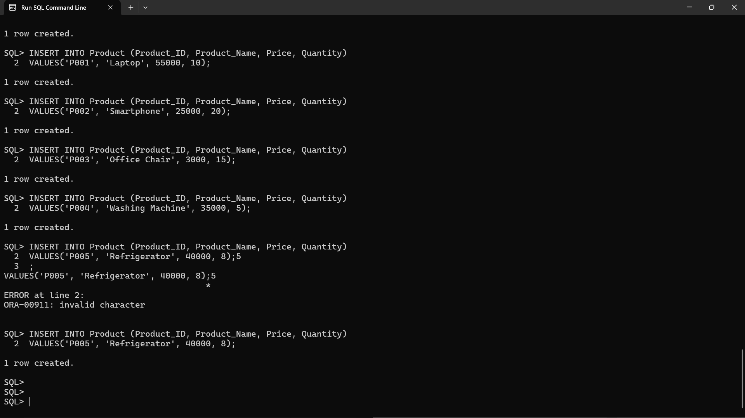

**Customer Table**

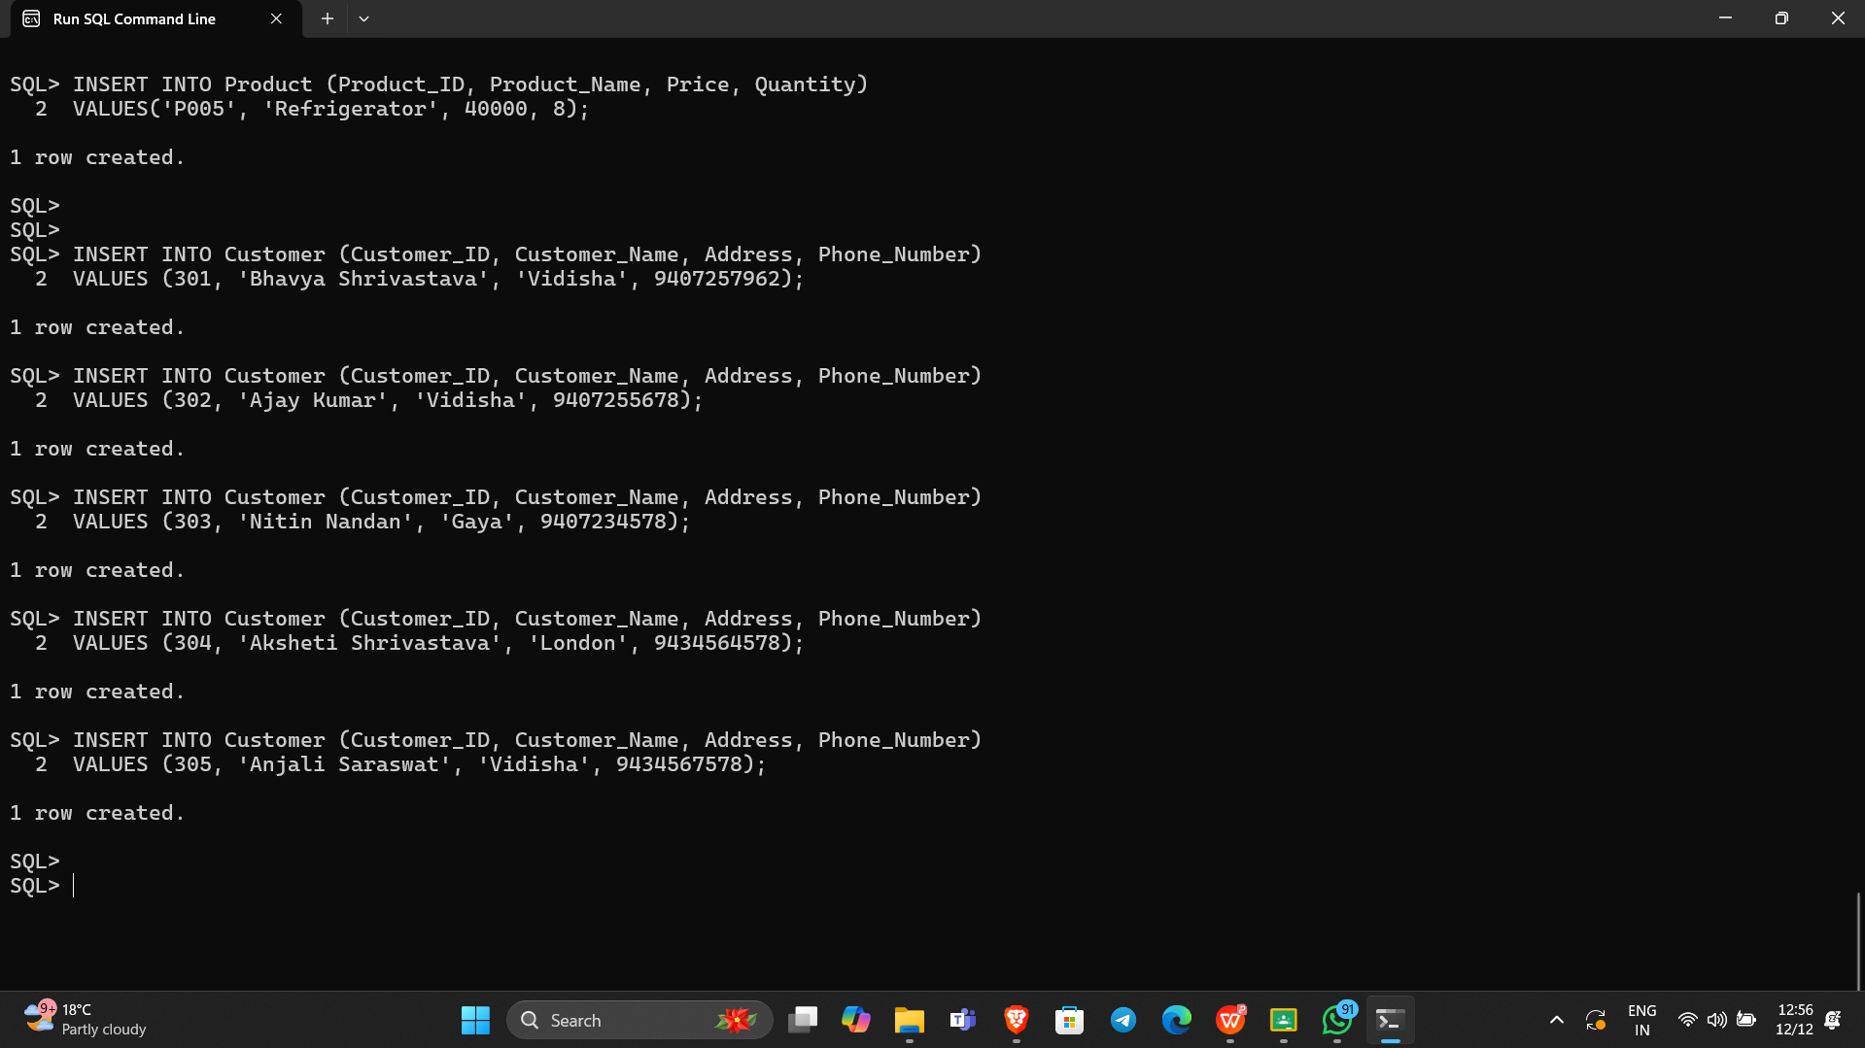

**Account Table**

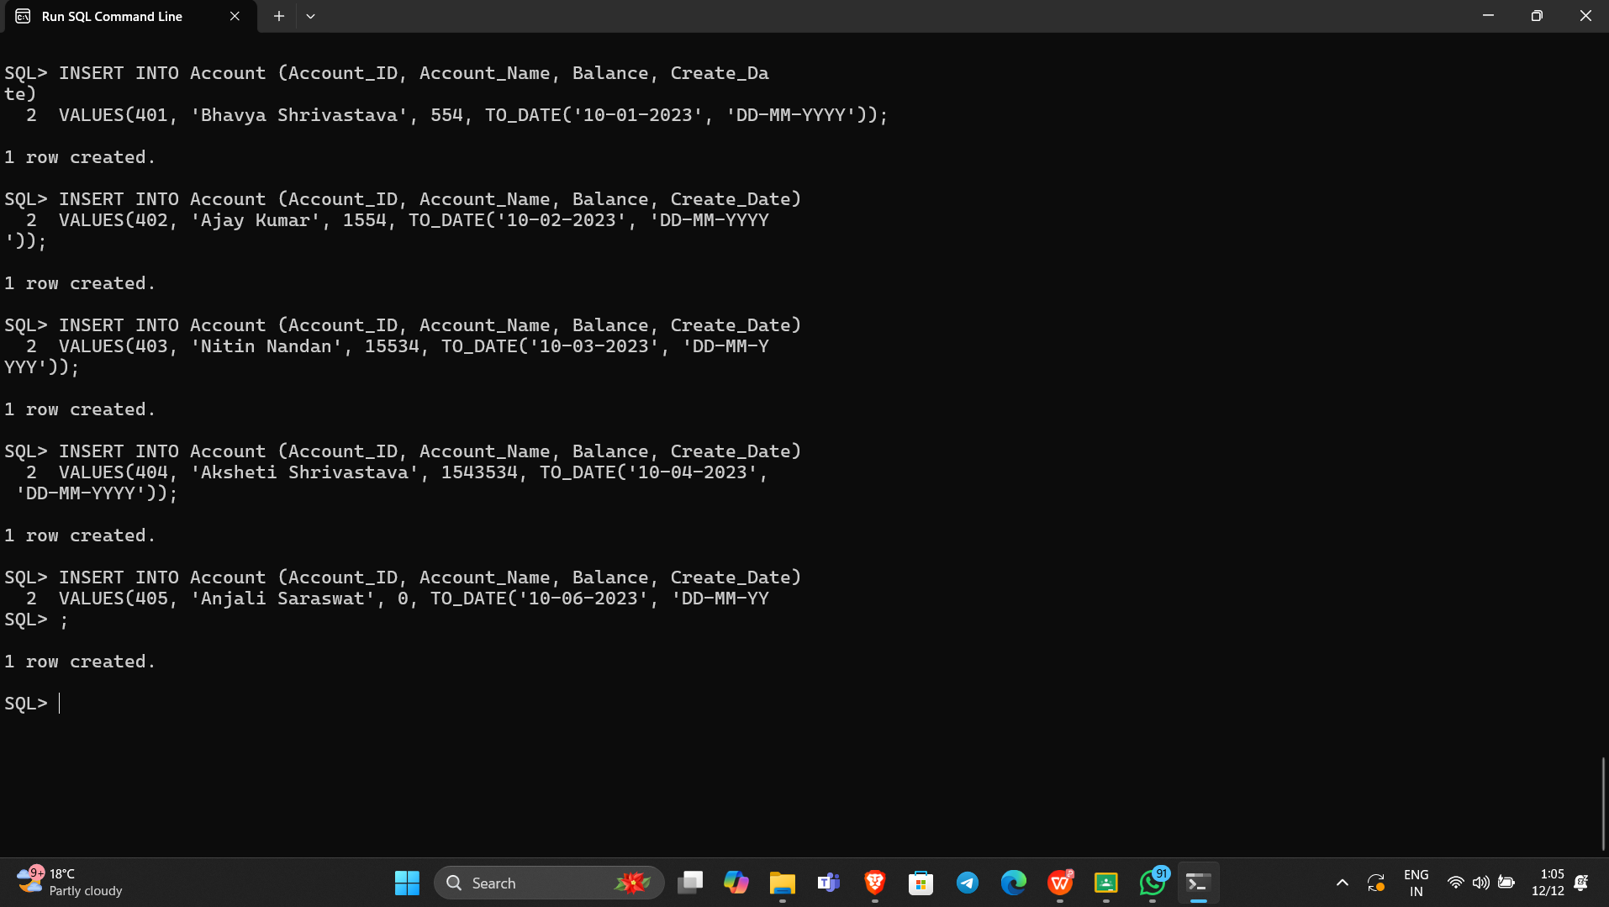

1. **Fetch all data from the respective tables.**

**Student Table**

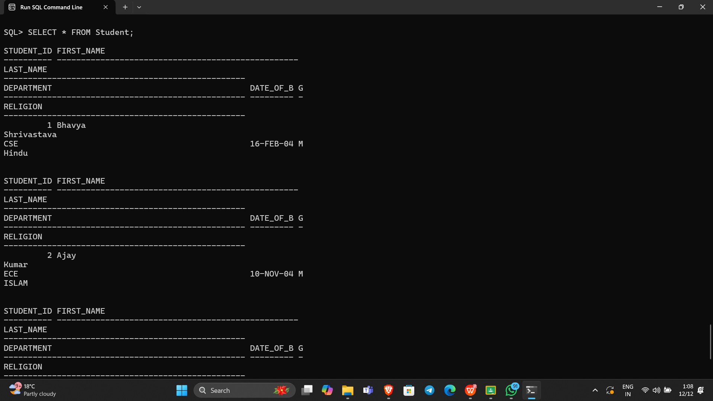

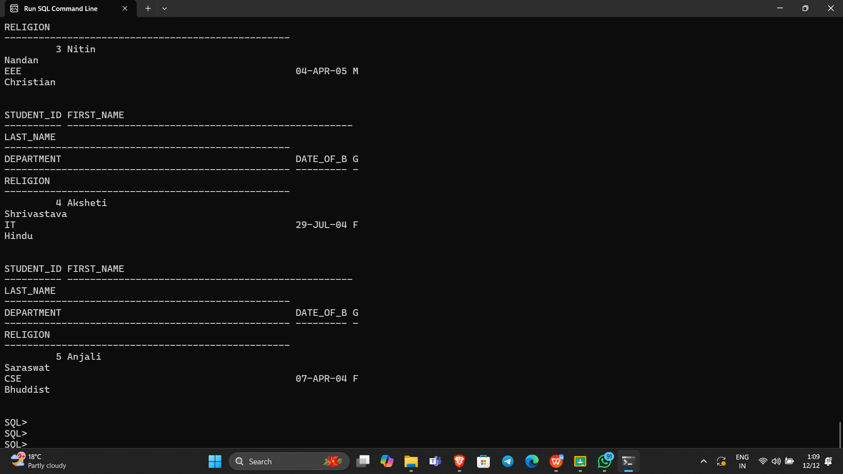

**Employee Table**

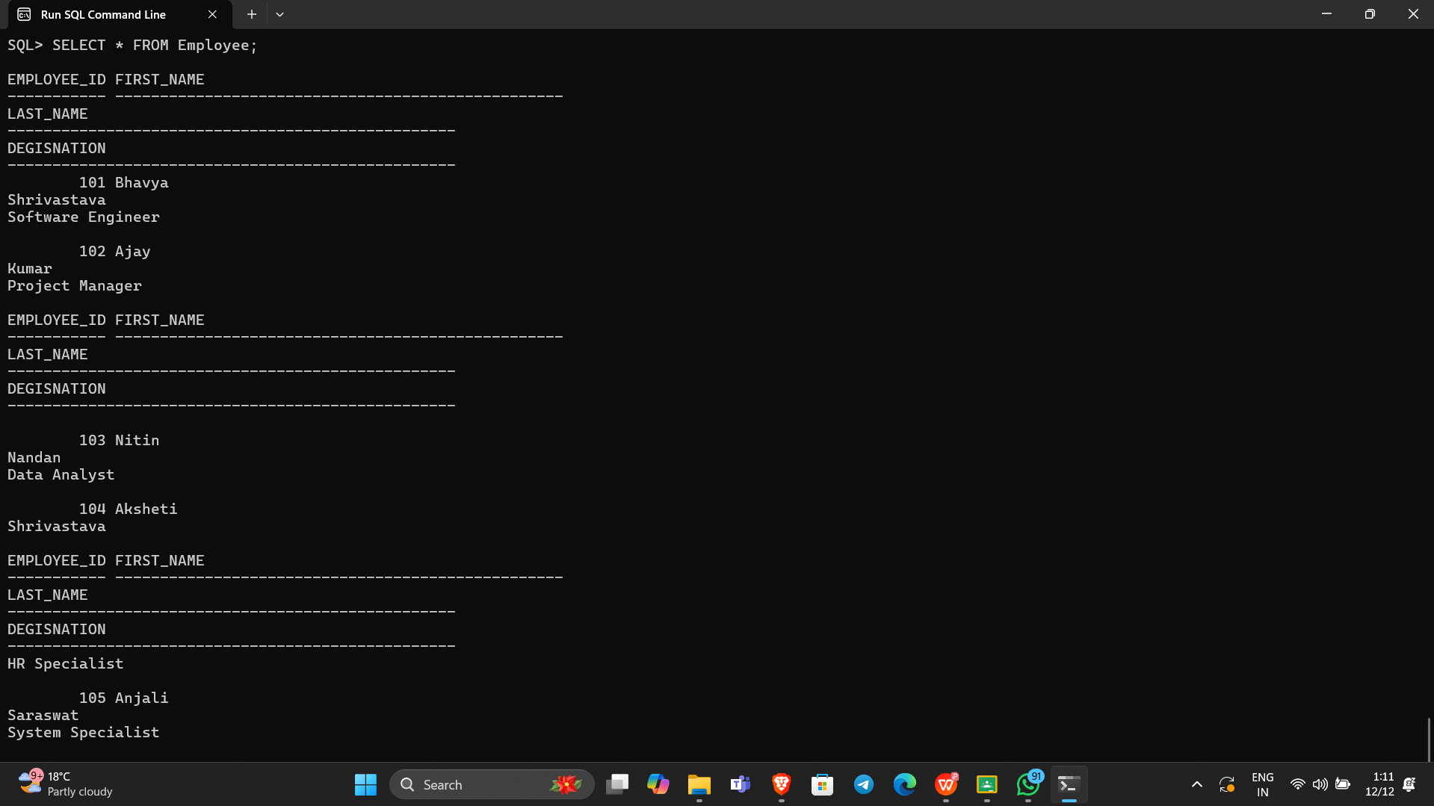

**Product Table**

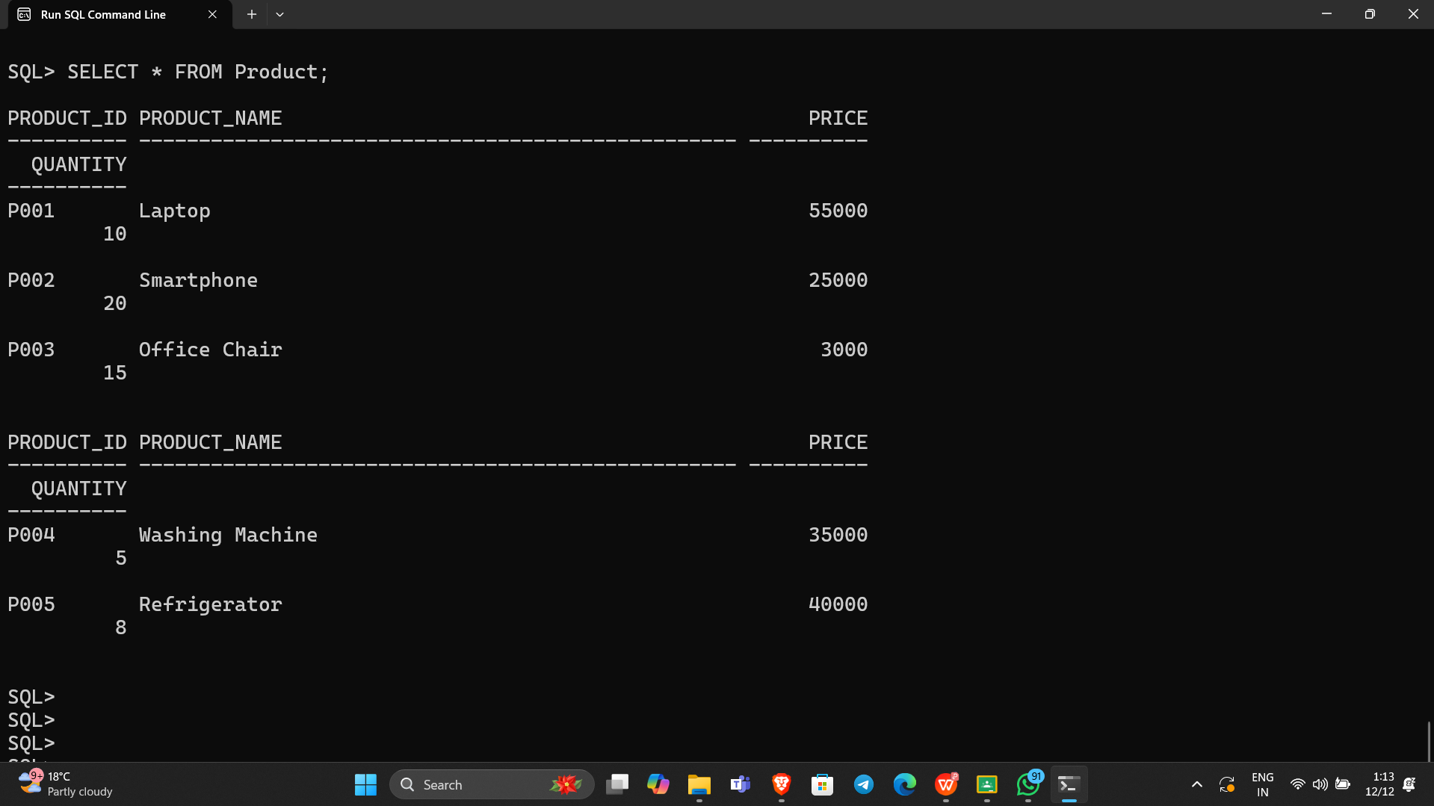

**Customer Table**

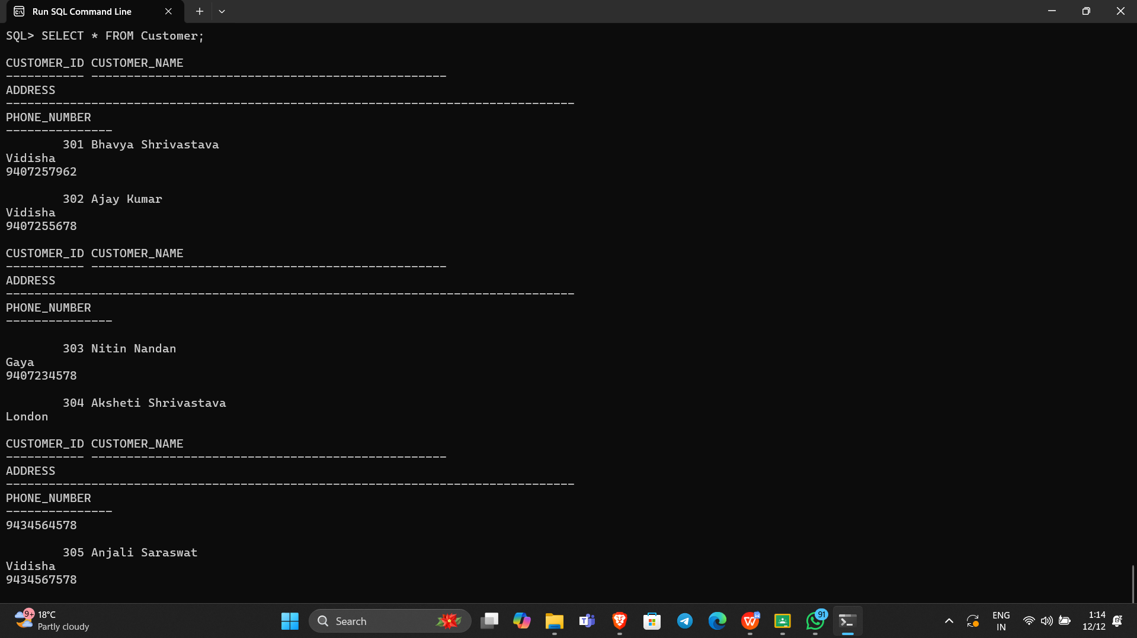

**Account Table**

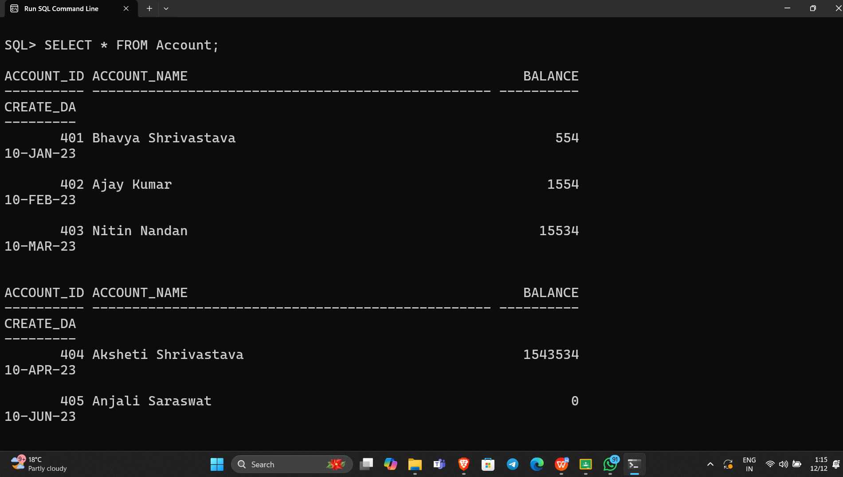

1. **Fetch Employee ids and their names from Employee table.**

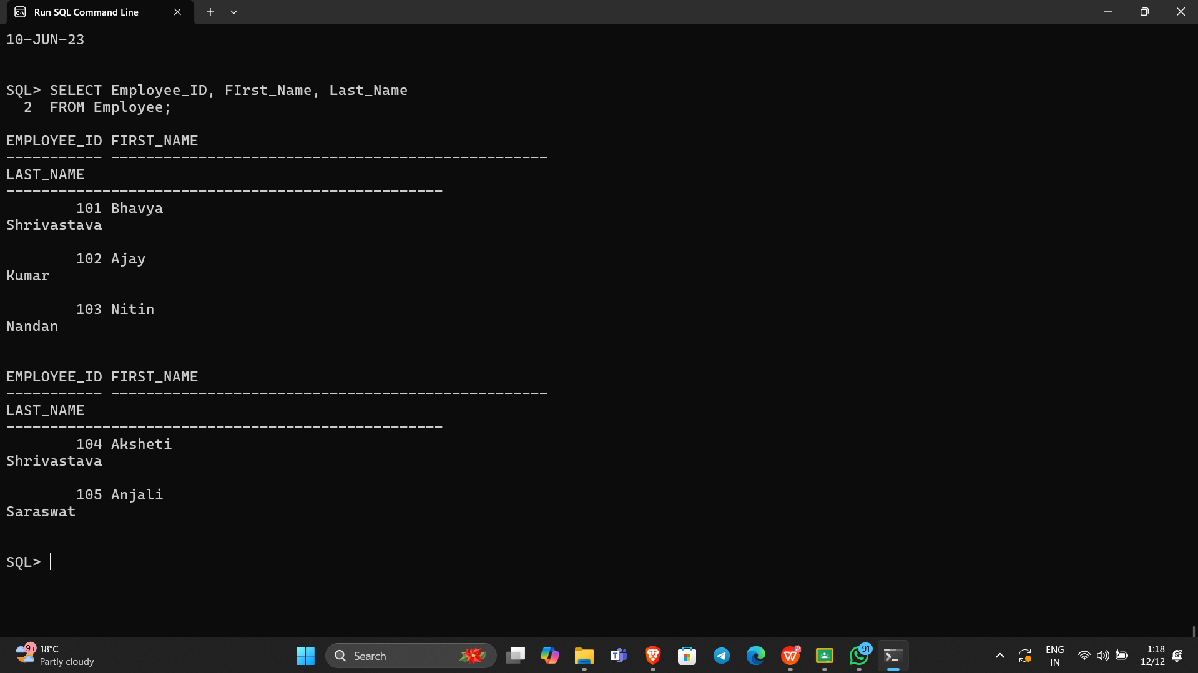

1. **Create table YOUTH (f_name, l_name, sex, DOB) from the Student table.**

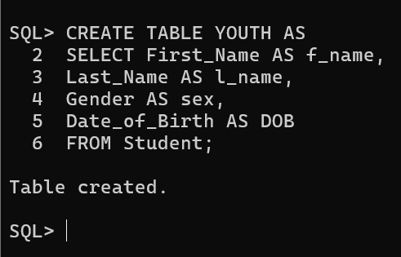

1. **Delete all data from the customer table.**

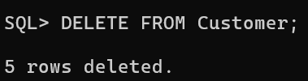

1. **Delete the Account table.**

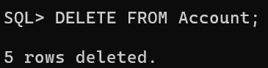

1. **Fetch the f_name and DOB from YOUTH table.**

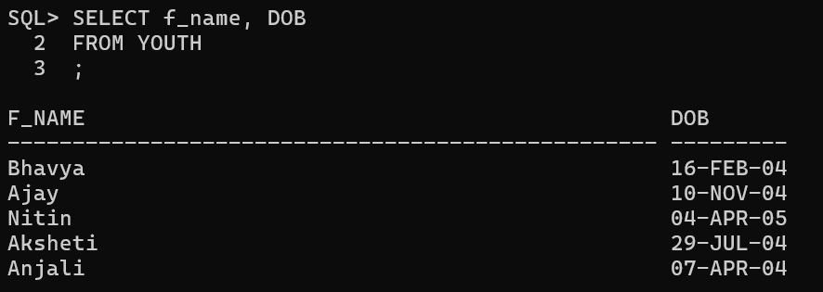

1. **Insert a new record into the Youth table. And keep NULL value in the l_name column.**

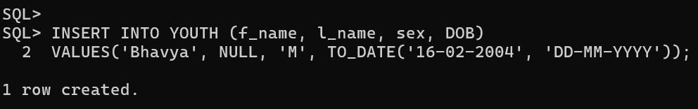

1. **Insert a new record into the Employee table. And keep NULL value in the employee_id column.**

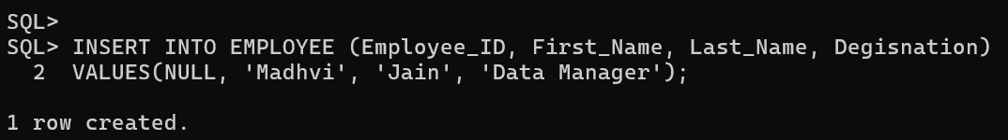

1. **Change the name of the employee table to workers.**

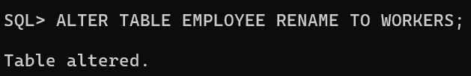

1. **Increase the size of the dept field in the student table by 10.**

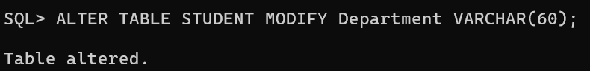

1. **Add a column ph_no in the student table.**

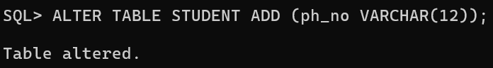

1. **Drop the religion attribute from the student table.**

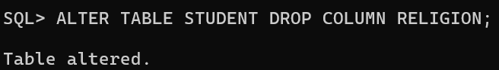

1. **Rename the student_id field to roll_no in the student table.**

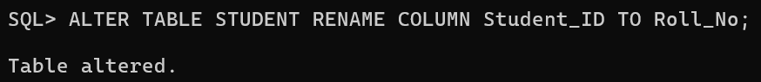

1. **Change the datatype and size of the product id column in the product table.**

